Assisting Small, Minority-Owned Businesses: A Blueprint for Economic Resiliency in the Pandemic Context in the ACOG’s 4 County Region
Roxana Cazan

Executive Summary
This project measures the quality of communication between a community and its elected local officials, particularly in the context of the COVID-19 pandemic. Its scope is to assess the best ways in which elected and appointed officials can assist and support local small and minority-owned businesses to survive and thrive. To this end, ACOG designed and distributed two surveys. The data collected was analyzed through a mix of qualitative and quantitative assessments. The results of this study suggest that:
- Small and minority business owners tend not to seek out engagement with their local Economic Development Agency and other business organizations;
- Small and minority business owners tend not to communicate their issues and concerns with their locally elected officials (mayors, council persons, county commissioners, and representatives);
- Small and minority small business owners need a more transparent and equitable access to business educational tools, resources, toolkits, etc.;
- Citizens tend not to trust their elected and appointed city leaders;
- Locally elected and appointed officials tend not to have a clear sense of what their community mostly needs as a result of the pandemic;
- Locally elected and appointed officials tend not to have a clear sense of what their community’s small business ecosystem looks like;
- Locally elected officials tend to avoid addressing issues of equity;
- Locally elected leaders tend not to engage all citizens in participatory citizenship.
We propose the following framework to help alleviate the issues observed:
- Local government equity
  - We must offer diversity, equity, and inclusion (DEI) trainings, conversations, strategies, and programs for our local governments and Economic Development Districts in order to highlight the difference between equity and equality and the need for equitable solutions for economic resiliency. At ACOG specifically, we must begin with a revision of our local Comprehensive Economic Development Strategy to include a specific DEI goal.
- Equitable community and economic growth
  - We must engage in targeted local small and minority-owned business outreach though partnering with other organizations.
  - We must provide an easy to navigate and accessible resources repertoire for minority-owned and women-owned businesses that can help mitigate inequity.
- Equitable community engagement
  - We must mitigate shortcomings of traditional public formats and forums in order to create new potential for engagement and innovation.
***

That the COVID-19 pandemic disturbed Oklahoma’s economy is an unfortunate reality. However, in order to understand the extent of this calamity, one must consider the ways in which the pandemic also upset local policy, governance, and public works, as areas that shape economic prosperity. Additionally, the pandemic contributed to exacerbating social issues such as inequality and inequity, which also have profound economic effects. Since a comprehensive study that measures the impact of the COVID-19 pandemic in Oklahoma has not yet been done, this project represents the first attempt at understanding local governance practices in the 4-county region overseen by the Association of Central Oklahoma Governments (ACOG), in order to prepare ACOG to respond to pandemic consequences adequately, to support the small and minority-owned business ecosystem, and to better serve its communities in general.
This project hopes to measure the quality of communication between a community and its elected local officials, particularly as a result of the pandemic. To this end, the study will provide answers to the following 4 main questions:
- What are ACOG area elected officials’ perceptions of economic and community development needs & wants in their respective districts, particularly in the context of the pandemic?
- What are the perceptions of communities comprised within our ACOG area regarding their community and economic development needs & wants?
- What do small businesses, particularly minority-owned businesses, within our ACOG area require to survive the pandemic?
- To what extent elected officials and their respective small business communities agree on priorities?
In addition to these main goals, the study reveals the kind of assistance the main contributors to local community development & economic prosperity—small and minority-owned businesses—require in order to navigate the COVID-19 pandemic. This information will be useful for ACOG as it is creating and populating its new live ACOG Dashboard. Additionally, the study will allow ACOG to become more involved with intentionally supporting local small, minority-owned, or women-owned businesses, a mission atypical for a regular Council of Governments (COG).
ACOG issued 2021 COVID-19 pandemic Update to the 4 county-region’s 2019 Comprehensive Economic Development Strategies (CEDS). The second goal listed in the Update is Resiliency, and it aims to “build a resilient economy through business development and attraction, diversification of the economic base, and adopting policies to address social, economic, and environmental disruptions.” In particular, the goal lists “enhancing availability and access to training and certification programs for small, minority-owned, and women-owned businesses” and prioritizing partnerships and collaborations especially with organizations such as Main Street Programs, chambers of commerce, small business associations, universities and career techs, and minority- and women-owned business organizations which are providing vital resources and support for businesses.” The present study helps implement this goal.
This study entails the design and distribution of two surveys—one to the locally elected and appointed leadership and one to the small and minority business community—and data analysis through a mix of qualitative and quantitative assessments. The results of this study can help ACOG:
- determine types of involvement ACOG can undertake to alleviate communication issues between local officeholders and their body politic, should it be determined that they exist;
- better advise elected officials in our region on the priorities for economic development in their areas, especially as we navigate the effects of the pandemic;
- better utilize the ACOG live Dashboard and the Updated CEDS to serve the realistic needs of communities within our jurisdiction, particularly those of small, minority-owned, and women-owned businesses.
Context
City leaders strive to understand the needs of their communities, so that they can strategize ways in which these can be addressed. Often, however, the needs and the wants of a given community do not overlap. Perhaps the city leadership’s viewpoint is skewed by certain factors. Perhaps city leaders may not have access to data that offers a complex overview of the community, their sense of security, prosperity, empowerment, and access to resources. Sometimes city leaders may make omissions, mistakes, and poor choices, which also prevent them from understanding their communities’ most urgent needs.
Without understanding their communities’ basic needs and wants, local city leaders cannot make quality policy decisions and address the priorities in their cities/town/counties. The pandemic has encumbered even more the ability of city leaders to obtain realistic data from traditional approaches (such as elections or community meetings) that allow listening to residents and local businesses. Not only are community meetings and public hearings difficult to organize during a pandemic, but they typically tend to be infrequent even outside the context of the pandemic. They also tend to yield a skewed representation of voices in the community. Too often city leaders consult solely economic indicators—unemployment rates, housing costs—as they attempt to understand their communities’ priorities. As a result, the lived experiences of residents are often ignored.
Even when looking specifically at community and economic development, the available economic indicators may not paint a full picture of the reality. For example, unemployment rates—the most common measure of economic development—are determined considering only those individuals who file for unemployment. Those who do not, remain excluded from statistical studies. Similarly, many small businesses that may close temporarily or permanently may not file for bankruptcy immediately. Some small businesses that closed temporarily to be able to survive the pandemic’s spikes may be forced to permanently terminate their activities. Other small businesses may not yet be incorporated, may not have a recorded financial history, or may operate in a language other than English and may utilize cash only. Studies about the pandemic have already suggested that minority individuals are being disproportionately affected by COVID-19 when considering health risks. Have minority-owned businesses also suffered more than white-owned small businesses according to the same pandemic logic? What kind of government support do people and businesses need, so that they may move on with life and prosper?
Entrepreneurs and small businesses (firms or farms) constitute the backbone of local economy. Understanding the impact they have on economic competitiveness is key to drafting policies that are effective but also inclusive and equitable. These policies should inspire social dialogue and bring together the community, businesses, and government actors to support existing local capacities and make way for the development of new ones.
Small businesses represent most of Oklahoma businesses; they employ more than half of the working population, many of whom are self-employed minority individuals. As one of the most devastating effects of COVID-19, many small business located within our ACOG region were forced to close indefinitely, thus bearing upon the unemployment trend. The retail sales tax revenue collection in Oklahoma constitutes the only means for funding day-to-day municipal operations. If businesses close, tax revenue decreases, and communities cannot operate properly. Locally elected or appointed leaders must understand the ways in which they can better serve the small and minority-owned business community, in order to ensure economic vitality through the pandemic.
That ACOG is an entity that advocates for regional cooperation, addresses, and solves common issues, promotes efficient government services, and strives to improve the quality of life in Central Oklahoma is widely known. Precisely given this mission, however, ACOG must understand not only how cities communicate with their elected and appointed leadership, but also the ways in which priorities are set, the context of these priorities, and their nature in order to determine the most efficacious, sustainable, and equitable ways to address them. ACOG also strives to promote equality and sustainability for all our community members, local businesses, local industry, and local government. The present study offers the metrics to allow ACOG to determine the success of its vision as outlined in the pandemic Updated CEDS.
Harlem Renaissance African American poet Langston Hughes describes the struggle of the American people as he hints at the proverbial American dream where “opportunity is real, and life is free, equality is in the air we breathe.” If we agree that everyone’s desires converge towards the same goals—to live dignified and healthy lives, participate at the decision-making table, make a good living wage, and enjoy our loved ones—we must also determine what we can afford to sacrifice in times of economic austerity, social injustice, political disenfranchisement, or global health crises. So how can local elected officials best determine what our communities most need by engaging all voices equally?
The COVID-19 Pandemic
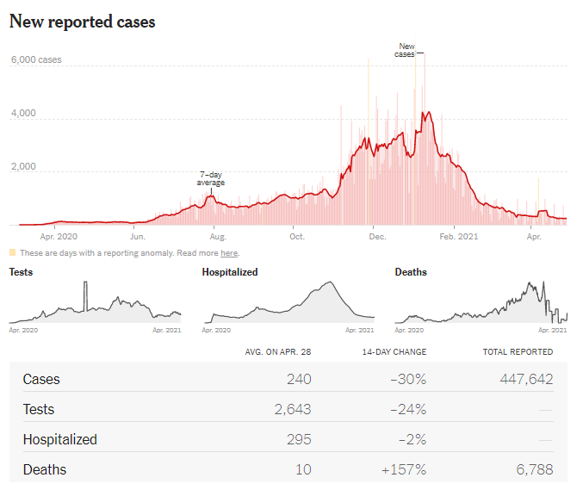
A newly discovered coronavirus, COVID-19 causes a respiratory illness first detected in Asia at the end of 2019. Since then, the outbreak of the COVID-19 illness spread globally into a pandemic. The first set of individuals in the United States who tested positive for this virus were identified in January 2020. The virus has since spread across all 50 states. The World Health Organization declared the coronavirus outbreak a pandemic on March 11, 2020. Four days later, Oklahoma Governor, Kevin Stitt, declared a state of emergency. The number of individuals testing positive for COVID-19 in Oklahoma remained high in the early 2021, with about 316 new infections recorded each day (as of February 2021).
Figure 1. The graphic depicts a spike in newly reported cases in Oklahoma peaking around January-February 2021. Image courtesy of The New York Times, April 29, 2021.

The Minority-Owned Small Business Landscape in Central Oklahoma
The US Census Bureau defines a business as minority-owned if 51% or more of the stock or equity in the business is owned by the listed categories below.
- Ethnicity: Hispanic; equally Hispanic/non-Hispanic; non-Hispanic.
- Race: White; Black or African American; American Indian or Alaska Native; Asian; Native Hawaiian or Other Pacific Islander; or some other race.

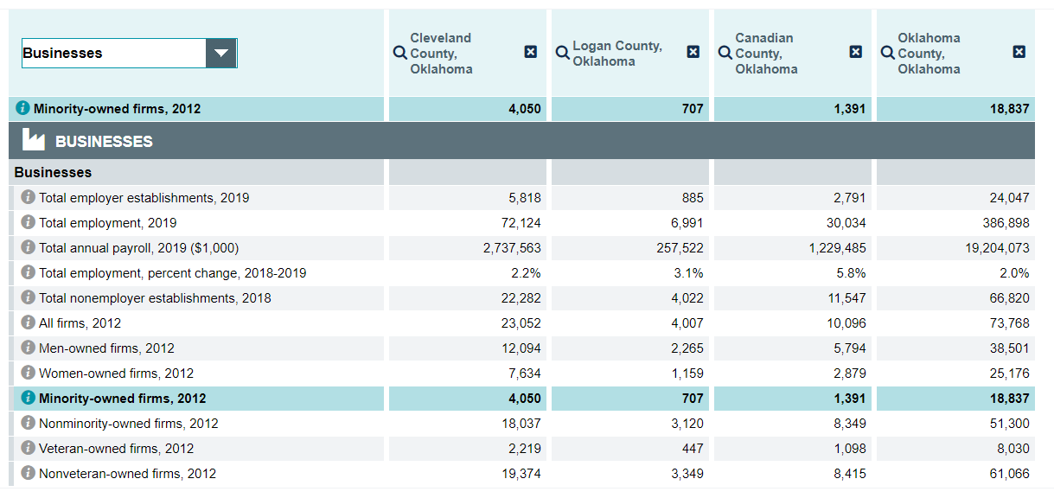
Figure 2. Table extracted from the US Census data collected in 2012 and found at this link:https://www.census.gov/quickfacts/fact/table/clevelandcountyoklahoma,logancountyoklahoma,canadiancountyoklahoma,oklahomacountyoklahoma/SBO030212

According to the U.S. Census small businesses data, there were 24,985 minority-owned businesses in ACOG’s 4 county region and 36,848 women-owned businesses in 2012 (Figure 2).
In 2019, 350,718 small businesses operated in Oklahoma, representing 99.4% of all Oklahoma businesses and employing more than half of the state’s work force. For example, according to the Census Bureau, in 2012, there were 6,158 white-owned manufacturing firms in the Oklahoma Metropolitan area, compared to 86 Black- or African-American-owned. Similarly, there were 27,555 white-owned retail businesses compared to 782 Black- or African American-owned. These businesses also employ about 100,000 of the state’s Black, Indigenous, and People of Color (BIPOC) individuals, representing about 17% of the state’s BIPOC population.
That severe disparities between American small businesses owned by white people and those owned by minority individuals exist in the US has been amply demonstrated. Among BIPOC business owners, Black entrepreneurs in particular tend to suffer the most, despite a notable growth in the number of Black-owned businesses in recent years. Average annual sales for a Black-owned business amount to about $58,000; in contrast the average white-owned enterprise tends to make nearly 10 times that amount. Similarly, Black women-owned businesses earn on average a net revenue of $24,000 in a year, compared to the average net revenue of $142,900 among all women-owned businesses. It is then expected that the pandemic and its ensuing economic recession would have affected minority-owned businesses in more severe ways.

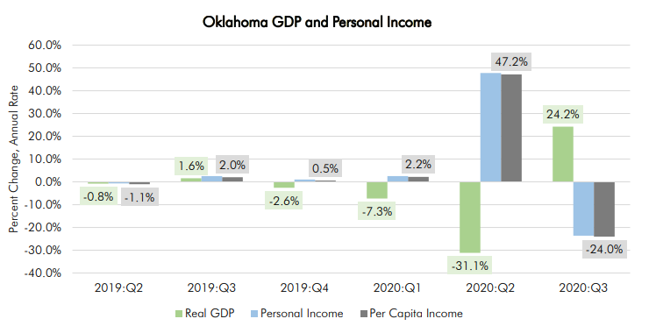
Figure 3. http://www.greateroklahomacity.com/clientuploads/pdf/Economic_Forecast_2021.pdf
As a Greater Oklahoma City Economic Forecast Report for 2021 indicates, the beginning of the pandemic year brought a spike in personal income and per capita income; however, these soon declined in the third quarter of 2020, and because federal programs pumped millions of dollars into relief programs, the real GDP began to rise (Figure 3). Surely our counties and municipalities have suffered tremendous losses during the pandemic months. Many lives were lost or impaired; students were unable to see their teachers and colleagues; people lost jobs and businesses; prices went up; the infrastructure deteriorated; relationships between people grew distant or sour. However, when considering local economic wellbeing, one must also account for the status of small businesses, as drivers of local wealth and community development. Given the aforementioned data, minority-owned businesses in Central Oklahoma constitute an important factor in regional economic development.

Survey Methodology
Two surveys were created. The first survey, entitled “COVID-19 Impact for Community & Economic Development,” was distributed among locally elected and appointed officials such as mayors, council persons, county commissioners, city clerks, and city managers. The distribution took place via mass email. We were able to track the number of email openings and to prompt individuals to respond to the survey. A reminder was sent out five days after the first email contact. A blog post followed this reminder four days later.
The second survey, entitled “COVID-19 Impact for Small and Minority-Owned Businesses,” was distributed among small business owners with attention to minority- and women-owned business owners. This survey was publicized with help from the local Chambers of Commerce, nonprofits, local Economic Development Organizations, local government officials, and business associations. We also approached distribution on social media groups and by direct email. The message accompanying the link to the second survey consisted of brief written and video invitations for participation. We created two short videos to accompany social media distribution.
The first survey remained active for a month, and the second for two and a half months.

Results
The First Survey: “COVID-19 Impact for Community & Economic Development”
This survey was distributed to ACOG’s Board Members. Of them, 62.5% took the survey. Well over half of the respondents identified as male (66.67%) and Caucasian (87.50%). Only 8% of the respondents identified as BIPOC individuals. While most respondents identified as white of European heritage, a few respondents utilized phrases such as “Judeo Christian Americanism” and “I'm American, period.” These answers combined with comments such as “to have so much of this survey devoted to the separation and identification of race and ethnicity is, frankly, unAmerican,” underscore a profound discomfort among locally elected and appointed officials in ACOG’s four county region with their racial, ethnic, and gender identity.
The respondents identified as residents of all four counties covered under ACOG’s jurisdiction, and of 50% of its municipalities. Most responses came from individuals representing counties or city halls with up to 10 employees on the administrative staff. However, over half of the respondents operated a budget over $5,000,000 in the 2020—2021 fiscal year. Forty-eight percent of the respondents described their community as middle income (MI); and 32% described their community as low-to-moderate (LMI) or low income (LI) (Figure 4).
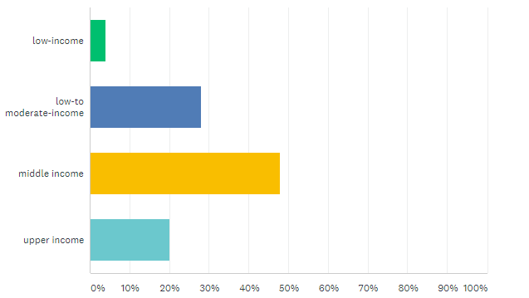
Figure 4. Survey answers to the question "How would you describe your community in terms of income?"
When asked to identify the three most severe issues their communities struggle with, the respondents identified the following: 42.86% of the respondents stated that their most severe issue is poor transportation and water infrastructure; 33.33% answered that their community’s second serious issue is also poor infrastructure; crime, domestic violence, and a lack of COVID-19 support were equally identified as the third serious issue in the respondents’ communities.
When asked whose behavior or what environmental problems must change for the issues to begin to be resolved, the respondents listed the following solutions ranked in the order of most frequent mention:
- fixing local infrastructure
- pursuing and receive better funding
- cultivating more small businesses
While most respondents described some of their communities’ most severe issues as pertaining to transportation and water infrastructure, a couple of answers identified “racial inequity/inequality,” “funding inequity,” “systemic racism,” “unequal access to education, employment, healthcare, and appropriate crisis services,” and “homelessness” as issues preventing community and economic development locally. Unlike the straightforward solution to an infrastructure issue, the development of social, economic, educational, and political systems that are equitable and inclusive is complex.
Most respondents agreed that the COVID-19 pandemic has had a powerful impact on their communities in terms of economic recession, unemployment, revenue declines, and reduced public service. The respondents overwhelmingly agreed that the pandemic affected local small businesses negatively. When asked whether the relief monies available through the CARES Act were enough to meet small business needs, the respondents stated that there was a moderate gap between what was available and what was needed.
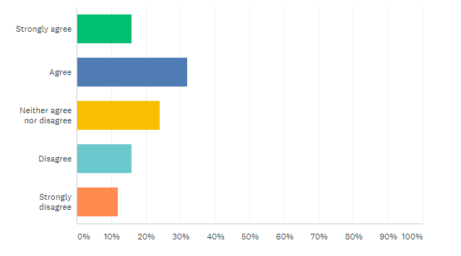
Figure 5. Survey answers to the question "“Minority-owned small businesses suffered more than any other small business given the pandemic.”
However, 52% of the responses do not agree with the statement that “Minority-owned small businesses suffered more than any other small business given the pandemic” (Figure 5).
When asked if minority-owned small businesses need different types of support than non-minority-owned small businesses, and if yes to explain their answer, only 20% of the respondents agreed with the trends observed both nationally and locally. These 20% suggested that the kind of support designed for minority-owned businesses must afford them access to equitable resource, thereby acknowledging a history of systemic inequality that places minority-owned businesses at a disadvantage. One of the respondents, however, pointed out a blind spot many elected or appointed officials may struggle with as they affect and enact equitable policy. The respondent explained that inequalities may exist but are not visible.

The Second Survey: “COVID-19 Impact for Small and Minority-Owned Businesses”
Quantitative Results
Because we do not know how many individuals received the survey, we are unable to determine the percentage that responded. Well over half of the respondents identified as women and 48% of the respondents identified as BIPOC. However, 88% of the respondents identified their business as minority-owned (Figure 6). Most of the respondents work for very small businesses, employing less than 10 individuals.
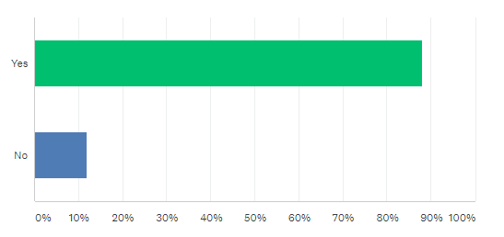
Figure 6. Respondents’ answers to the question of whether their business identifies as minority-owned.
A third of the respondents stated that they never communicate with their elected or appointed officials and most do so to market their business, affect policy change, or to be seen in public meetings. However, only 33.3% of the respondents named two or more of the locally elected and appointed officials in Oklahoma City alone, such as mayors, council persons, and city managers.
An overwhelming percentage of respondents were unable to express an opinion on the level of engagement of locally elected and appointed officials in actions and activities dedicated to help small and minority-owned businesses navigate the pandemic. Similarly, they were overwhelmingly unsure of how supportive locally elected and appointed officials are of businesses like theirs.
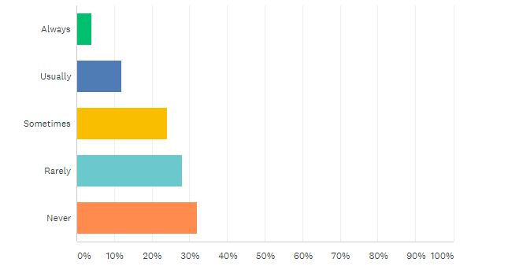
Figure 7. Respondents answer to the question of how often they communicate with their locally elected or appointed officials.
Fifty percent of the respondents indicated that they belong to a local business association.
In terms of assessing the COVID-19 pandemic impact, 45.83% responded that they had to close their business temporarily during the last pandemic year. Of these, most also identified as BIPOC or women. Respondents underscored the major types of impact their businesses suffered; these were: revenue expectations, access to capital, availability and cost of materials, and access to professional and personal development. Only half of the respondents applied to the Paycheck Protection Program and most of them received financial assistance through the PPP. Half of the respondents indicated agreement with the statement that minority-owned businesses suffered more than corresponding white-owned businesses as a result of the pandemic. Over 43% of the respondents indicated that their mental health suffered during the pandemic.
Seventy-one percent of respondents stated that the pandemic will have a lasting negative impact on their business and that they do not have expectations that their locally elected or appointed officials can or will help alleviate pandemic effects.
Among the local resources small and minority business owners need, three rank at the top (Figure 8):
- access to and assistance with applications for grants and loans;
- advocacy;
- access to a central, online repository for resources and information.
The respondents also indicated a desire to see the following assistance come more prominently from their local chambers or economic development districts:
- free webinars/workshops addressing issues faced by minority-owned businesses;
- financial assistance;
- marketing and branding resources;
- a better understanding of the legislative agenda with respect to small business development in Central Oklahoma.

Figure 8. Respondents’ description of what services and access would most benefit them.
The respondents were also asked to indicate what type of financial assistance they sought out and/or received during the 2020 pandemic year. Of the 50% who applied for a Paycheck Protection Program loan, 47% received it. Similarly of the 20% of the respondents who applied for loan forgiveness, 18% received it. However, almost 40% of the respondents did not request or receive any financial assistance to help in recovery efforts.

Figure 9. Respondents' input on what type of assistance programs they applied to during the pandemic.

In general, the majority of respondents indicated that they do not know to what extent their elected or appointed officials acted to help small businesses navigate the pandemic (Figure 9).
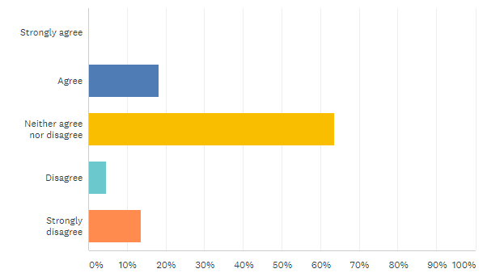
Figure 9. Respondents' level of agreement or disagreement with the statement “My local elected officials were able to act swiftly to help my business navigate the COVID-19 pandemic.”.
They also overwhelmingly did not know whether their locally elected or appointed officials understand and support small and minority-owned businesses like theirs. When asked what expectations they have from the local officials in general, the overwhelming majority expressed their concern for community and for minority businesses. While 53% of the responses expressed incredulity at the ability of local officials to help and affect change, only 33% were very positive.
Qualitative Results
When asked about long-term consequences on their businesses that they expect as a result of the pandemic, the respondents fear serious financial loss, debt, and bankruptcy. The overwhelming perception is that support from local and federal leadership is close to nonexistent, which will affect small businesses going forward.
Analyzing respondents’ expectations from local elected and appointed officials in response to COVID-19, three themes surfaced: people expect help and support for small businesses in the shape of financial assistance, marketing, and access to resources; they also expect more direction and more attention to minority-owned businesses in terms of equity and inclusion.
Almost 50% of the respondents skipped the question “What expectations do you have from your local elected officials, in general (not related to the COVID-19 pandemic)?” Two themes ensued from the responses offered. Respondents desire a more “aggressive” public presence and specific programs designed for minority-owned businesses that ensure equitable access to resources. However, an overwhelming trend indicated that respondents expect nothing from the local officials.

Discussion
A recent study demonstrates that 75% of small businesses nationwide have expressed concern at being able to operate despite the widespread access to vaccination promised by the US Administration. The three main reasons for concern stem from: 1. the lack of cash reserves with which to operate business if austerity continues, knowing that on average small businesses tend to survive particularly because of cash reserves; 2. inability to pay rent; and 3. the general struggle with obtaining Paycheck Protection Program (PPP) funds. Two-thirds of minority-owned businesses have indicated inability to pay rent in March 2021.
The pandemic intensified compounding disadvantage for BIPOC individuals nationwide. For example, 18.4% fewer self-employed Black people were working in July 2020 than there had been a year previously, compared to 6.2% fewer self-employed white people (the dips for Asian and Hispanic people were even smaller).
Minority-owned businesses overall have also been at the back of the line for relief programs, initially designed without factoring in the unique challenges of small businesses owned by BIPOC individuals. As a result, in areas with a higher percentage of minority residents, small businesses were able to access federal Paycheck Protection Program (PPP) loans much later. A survey conducted by the Global Strategy Group in May 2020, determined that only 12% of minority business owners received the PPP amount they asked for, while nearly 50% did not receive any help and indicated fear of permanent closure. In contrast, white business owners were able to receive PPP help much earlier.
National trends clearly suggest that the COVID-19 Pandemic impacted minority-owned businesses more severely than other small businesses for several reasons:
- Financial Wealth: Minority-owned businesses experienced financial distress prior to the pandemic.
- Size: Minority-owned businesses tend to be smaller than non-minority-owned businesses. They report more competition.
- Services: Minority-owned businesses typically offer services in the industries most affected by the pandemic.
- Inequality: Minority-owned business face more challenges than their non-minority-owned counterparts.

In Oklahoma City, Maurianna Adams, director of Progress OKC, addressed the Oklahoma City Council in October 2020 to highlight that minority businesses are affected much more by the pandemic than non-minority businesses. That same month, Cathy O’Connor, President of the Alliance for Economic Development of Oklahoma City announced the launch of the Minority Owned Business Recovery Program offering grant funding to assist with “payroll, rent, retrofitting the business, purchasing sanitizing equipment or other operational needs arising from COVID-19.”
John Veal, District Director of the Oklahoma District Office of the US Small Business Administration (SBA), underscored that BIPOC entrepreneurs take a chance opening a business that has a chance to survive. The main barriers they encounter may be explained by two phenomena. First, they operate in an area that is not fully racially integrated. This prevents customers from venturing out of their routine to offer patronage to businesses with which they might not be familiar. Because many such businesses have not had the chance to build a strong financial background, they struggle with receiving help from lenders.
Another obstacle has to do with these businesses’ location at the periphery of the downtown urban core. Apollo Woods, Director of the marketing company OKC Black Eats and lobbyist on behalf of Black entrepreneurs, suggests that these obstacles are rooted in century-long segregation practices substantiated though law. For instance, Woods quotes Senate Bill #1, approved in December of 1907 known as Oklahoma’s first Jim Crow law, which stated that public services and local businesses had to provide separate spaces and programs for white and African American customers.
Oklahoma’s black business owners have been hit hard by the pandemic, with the community in danger of losing half of their businesses by the time we navigate out of the pandemic, as suggested in an interview by the Oklahoma City Black Chamber of Commerce. Oklahoma’s minority-owned businesses faced a 13% denial rate for loans compared to non-minority businesses whose loan denial rate was at 8%. Paycheck Protection Program (PPP) loans have not reached many of the hardest impacted by the pandemic in the state. Many black business owners have been denied PPP loans if they did not have a prior relationship with the loaner bank. Clearly, pandemic trends for minority-owned businesses in Oklahoma mirror closely national phenomena.
One of the strengths of this study’s second survey is that it offered a voice for women minority business owners to articulate their concerns. One of these reasons could be the fact that, despite 2016 predictions according to which Oklahoma City constitutes one of the most supportive places in the U.S. for women entrepreneurs, today Oklahoma is one of the 5 U.S. states that offers the least amount of support for women-owned businesses, according to a 2020 Zippia career expert analysis of U.S. Census annual business survey data (Figure 10).

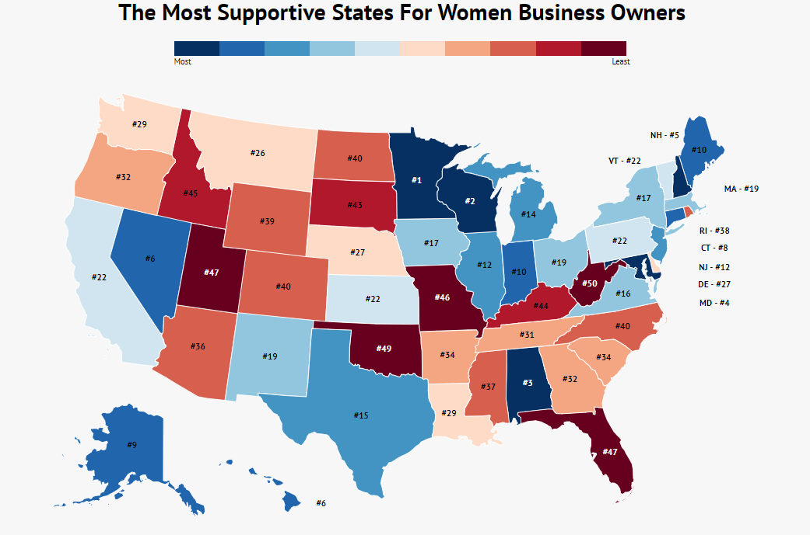
Figure 10. This map of the United States indicates that Oklahoma is one of the least supportive states for women business owners. Source: https://www.zippia.com/wp-content/uploads/2020/11/map-most-supportive-states-women-business-owners.png.

ACOG’s survey responses regarding the effect of COVID-19 on small and minority-owned businesses, particularly revenue decline and operational ability, reflect data trends in the state. Data indicates that revenue has declined by over 30% for LMI small business owners in Oklahoma since January 2020 (Figure 11). Similarly, as of April 28 2021, the number of small businesses open decreased by 31.1% compared to January 2020. As of March 10 2021, employment rates similarly decreased by 1.7% compared to January 2020, indicating not only that the pandemic has indeed affected people’s job security, but also that it has yielded a microculture of reliance on state and federal emergency support that stumps the desire to seek employment. This trend surely impacts small business owners who lost employees during the pandemic year 2020. To counter this culture, Governor Kevin Stitt signed into law a new return-to-work incentive.

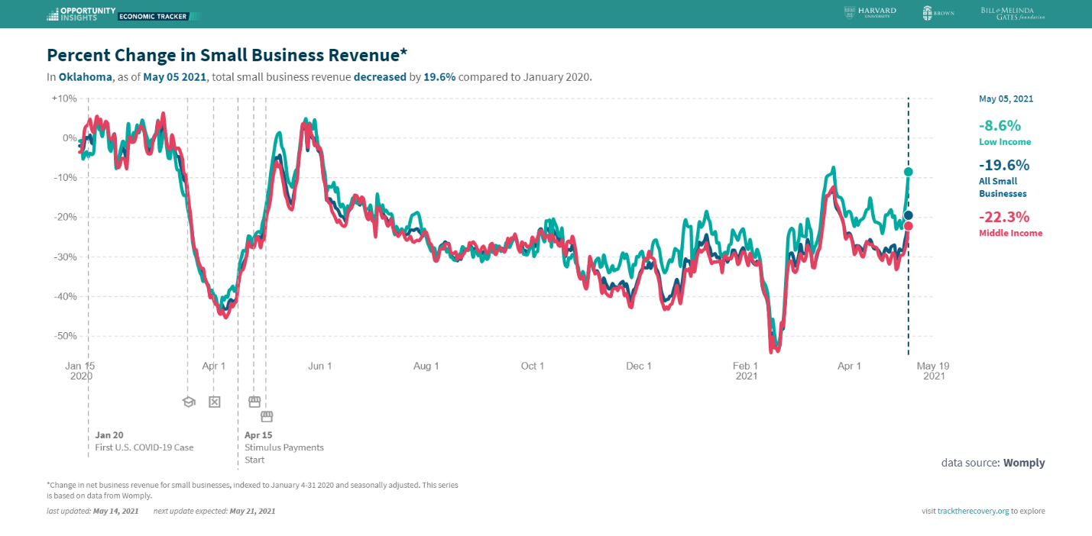
Figure 11. The graph suggests that low- and medium-income businesses in Oklahoma witnessed a sharp decline in revenue into 2021. Source: https://tracktherecovery.org/
While most economic development organizations and state government institutions in Oklahoma have already begun to respond to the disparities described above, locally elected and appointed officials in our region outside of the Oklahoma City area continue to remain oblivious to such discrepancies. As the first survey results suggest, by and large, they do not see a difference in terms of the needs minority-owned businesses have as being different than those of other small businesses. While they unanimously identify one of their top missions as to create unity and equality in their communities, they are unable or unwilling to see that the issues minority-owned businesses struggle with especially in the context off the pandemic stem from inequity.
Ultimately, the survey study suggests a few alarming points.
- Small and minority business owners tend not to seek out engagement with their local Economic Development Agency and other business organizations;
- Small and minority business owners tend not to communicate their issues and concerns with their locally elected officials (mayors, council persons, county commissioners, and representatives);
- Small and minority small business owners need a more transparent and equitable access to business educational tools, resources, toolkits, etc.;
- Citizens tend not to trust their elected and appointed city leaders;
- Locally elected and appointed officials tend not to have a clear sense of what their community mostly needs as a result of the pandemic;
- Locally elected and appointed officials tend not to have a clear sense of what their community’s small business ecosystem looks like;
- Locally elected officials tend to avoid addressing issues of equity;
- Locally elected leaders tend not to engage all citizens in participatory citizenship.

Conclusions and Suggestions
In an article for the Atlantic, Ta-Nehisi Coates argues that “the answer to the crisis in democracy is more democracy.” Participation is crucial to creating equitable and inclusive public life and civic spaces, and to heralding economic development. In order to transform communities in ways that eliminate destructive conflict, unites them, and renders them resilient, we must deploy participative mechanisms that empower each stakeholder by allowing them to shape both public space and civic life. That the COVID-19 pandemic has upset access to public participatory mechanisms and forced us to reinvent them has been amply noted. However, the challenge remains, even with adjustments that allow an individual to participate from the comfort of their own personal space, how can we ensure that all individuals have equal access to deployed mechanisms of public engagement?
Locally elected and appointed officials aim to do their very best in approaching the full range of stakeholder concerns and needs. However, in the struggle to empower all, sometimes they miss the opportunity to empower those who have systemically been denied access and public voice. A democratic process that considers the diverse, emotional, moral, social, and economic needs of distinct cultural communities is guaranteed to create brilliant and profitable outcomes. By democratizing the ways in which members of all communities participate in decision-making processes through mechanisms beyond voting, our municipalities and counties ensure not only equality but also equity as mechanisms that drive community and economic development, particularly in the context of the pandemic.
Both research and lived experiences demonstrate that an obsession with profits and market value to the detriment of social and environmental impacts creates an unsustainable environment. Similarly, short term community engagement for economic development may underscore a noble sentiment but it does not change a status quo of profit and inequality. For instance, helping a community build a much-needed playground in the summer only to determine that the money could have been better used to fix up the otherwise inaccessible school building constitutes only an attempt to cover up or expiate guilt at the inability to address systemic barriers to access. We must also subject ourselves to a rigorous critical examination. In light of this, then, how do we best determine the needs of our communities in order to create or design resources that would benefit them?
Survey studies like the one carried out by ACOG can help us create engagement and participation. However, barriers to reaching out to community representatives and members need to be rectified in order for the process to work smoothly. Our study suffers from an array of biases we list below:
- Access to public records of small and minority- or women-owned businesses in Central Oklahoma is difficult.
- There are no public databases to list up-to-date information on the currently operating small businesses in our region.
- People are unwilling to be studied. Particularly BIPOC and minorities in the US have always been the target of sociological, economic, or anthropologic investigations that yielded no or few direct benefits. People are tired of promises.
- We do not know the actual number of businesses our survey reached because we worked through partners. Distributing messages through a third party entail inherent risks.
- Because we do not know the actual size of the population targeted by the second survey, we are unable to assess sample bias.
However, the study allows us to propose a few solutions to the problems identified as listed below. ACOG is well poised to aid both our membership and our small and minority-owned business communities by providing opportunities for education, development, and sustainable local engagement. Specifically, ACOG should pursue:

- Local government equity
  - We must offer diversity, equity, and inclusion (DEI) trainings, conversations, strategies, and programs for our local governments and Economic Development Districts in order to highlight the difference between equity and equality and the need for equitable solutions for economic resiliency. At ACOG specifically, we must begin with a revision of our local Comprehensive Economic Development Strategy to include a specific DEI goal.
- Equitable community and economic growth
  - We must engage in targeted local small and minority-owned business outreach though partnering with other organizations.
  - We must provide an easy to navigate and accessible resources repertoire for minority-owned and women-owned businesses that can help mitigate inequity.
- Equitable community engagement
  - We must mitigate shortcomings of traditional public formats and forums in order to create new potential for engagement in participatory citizenship and innovation.

Nota Bene:
We want to offer special thanks to Mr. Apollo Woods, Mr. Thuan Nguyen, Ms. Alba Weaver, Ms. Joanne Davis, Mr. Ken Tally, Vice-Mayor Nikki Nice, Representative Cyndi Munson, Senator George Young, and Senator Kay Floyd for helping in our reaching-out efforts to minority-owned businesses.

We also want to offer our gratitude to our survey respondents; we recognize and appreciate your trust and labor, and we hope to help you thrive.

Women-owned businesses could also identify as minority-owned.

